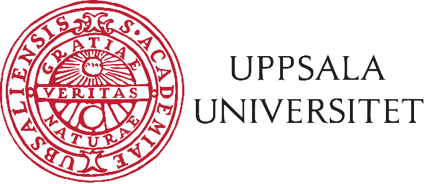
PhD Student Board
Medical Faculty
Agenda

The PhD student council of the Medical Faculty hereby invites you to the MDR meeting;
Friday 12th of October, 09:00, room A1:112b, BMC
Topics:
- Opening of meeting
- Election of corrector
- Co-options
- Adoption of agenda
- Confirmation of minutes of previous meeting
- Vacant positions
- Appointment of PhD student representation in boards and committees
- Messages:
  - Faculty board
  - Committee for PhD-students
  - PhD student board at Uppsala Student Union
  - PhD student board at Faculty of Pharmacy
  - Committee for the Medical Faculty
  - Recruitment board
  - Universitetsnämmnden/-styrelsen
  - Committee for appointment of associated professors/senior lecturers
  - Medicinska sektionsrådet
  - Library cooperation group
  - Committee for equal opportunities
  - SVEK
  - EXODIAB
  - Other messages
- UU language policy
- MDR events: timing & content
- MDR web-page and email ID
- Post-election MDR board dinner
- Next meeting
- Other matters
- Adjourning of meeting

